**WHAT WE DO**

We are a team of Computer Scientist, Engineers, Designers and Marketers with over 12 years of combined experience in client satisfaction. We deliver attractive, data driven, research fueled, technological and creative solutions for small to intermediate businesses. We pride ourselves on the organic experience, a passionate grass roots approach that helps our clients grow their businesses by understanding their ideas, markets and competitors.

Our goal is to expand the presence of our clients in and out of their markets, translating connections to customers. Wether the market is traditional or Digital (full disclosure, we prefer digital markets, simply because most quantifiable connections are digital) we are ready to provide tailored solutions to meet your business needs.

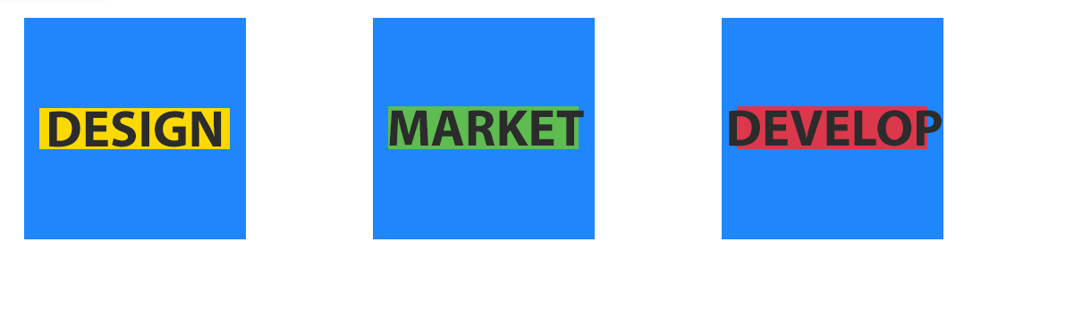

**CONTACT**

* **Email**

[mediarelations@bluescalestudios.com](mailto:mediarelations@bluescalestudios.com)

* **Address**

South Hills Cap Estate  
Saint Lucia

[Edit](http://bluescalestudios.com/wp-admin/customize.php?autofocus%5Bsection%5D=sidebar-widgets-footer-1&autofocus%5Bcontrol%5D=widget_wpcw_contact%5B6%5D&url=http%3A%2F%2Fbluescalestudios.com%2F)

**CONNECT WITH US**

# About



### Our Philosophy

Here at Blue Scale Studios, INC., we pride ourselves on the organic experience. Our goal is to give every client a product specifically tailored to their personal and business needs. Whether those needs are a unique mobile application or marketing advice, we are here to serve you. With a family-like mindset, Blue Scale Studios, INC. promises to help build the business you’ve always dreamed of.

### Our Story

Blue Scale Studios, INC., started out with humble beginnings. In 2009, a group of college friends, at Grambling State University, decided to embark on a journey that would lead them into the software development world. The name “Blue Scale” was chosen simply because it was easy to remember and left a mental image.  Today, Blue Scale Studios is incorporated and managed by Darnelle Fevrier, Senior Software Developer and Geeshian Avril, Senior Mobile Developer.

Currently, Blue Scale Studios, INC. is preparing for the release of their latest project, Passport®, a mobile ticketing and advertising platform.

### Meet the Team

Mediocre isnt ever acceptable. Thats why our team is made up of those who refuse to stop nothing short but perfection and excellence  
Why? Because people want to know who they’re doing business with. It’s a human thing.

### Darnelle Fevrier

Co-Founder & Lead Developer

Creating new applications with various technologies is his specialty



### Geeshian Avril

Co-Founder & front-end Developer/Graphics Designer

developing UI which is intuitive

### Next Steps…

Come let us discuss what we can build to help you meet your deadlines

# Services

### Product / Service #1

Whatever your company is most known for should go right here, whether that's bratwurst or baseball caps or vampire bat removal.

### Product / Service #2

What's another popular item you have for sale or trade? Talk about it here in glowing, memorable terms so site visitors have to have it.

### Product / Service #3

Don't think of this product or service as your third favorite, think of it as the bronze medalist in an Olympic medals sweep of great products/services.



### Talk more about your products here.

Tell prospective customers more about your company and the services you offer here.  Replace this image with one more fitting to your business.

### Talk more about your products here.

Tell prospective customers more about your company and the services you offer here.  Replace this image with one more fitting to your business.

# Let's Create Something Great!

We are Team of Computer Scientist, Engineers, Designers, Animators and Marketers with over 20 years of combined experience in Client Satisfaction. We deliver data driven, research fueled, technological and creative solutions for small to intermediate businesses. We achieve this by getting to know our clients, their needs, markets and end users in order to provide a digital marketing presence that embodies your companies goals.



### Next Steps...

This is should be a prospective customer's number one call to action, e.g., requesting a quote or perusing your product catalog.

[Call to Action](http://bluescalestudios.com/services/)

# Contact

Get in touch and we'll get back to you as soon as we can.  We look forward to hearing from you!